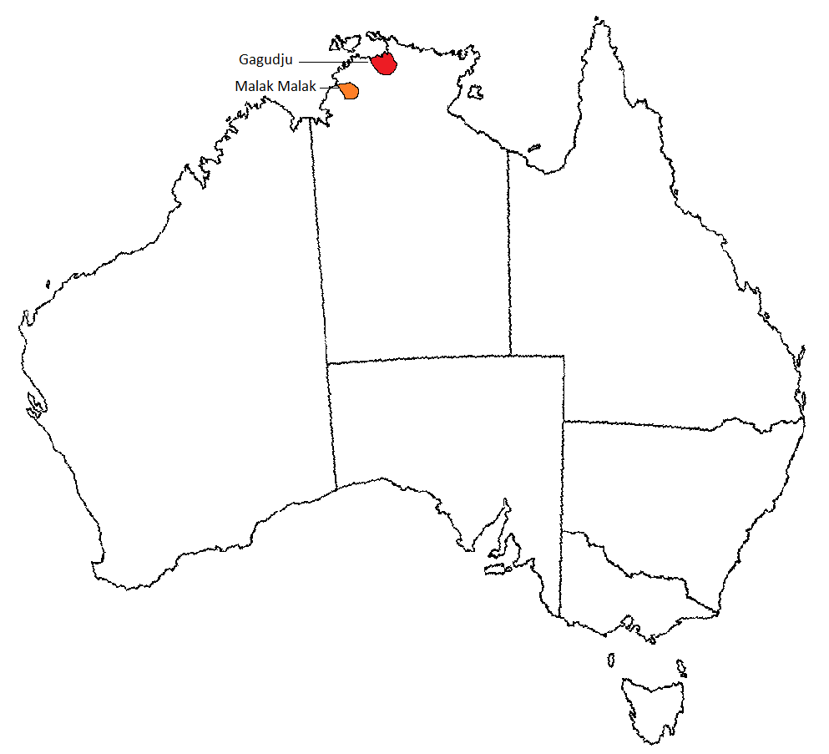
Location of the Malak Malak and Gagudju peoples’ land

